
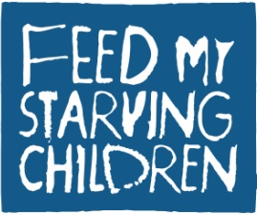
Sponsorship Opportunities
Food 4others MobilePack 2013

Dear Business Leader,

We are excited to announce the return of San Jose’s Food 4others MobilePack, an event that brings together hundreds of volunteers in hand-packing nutritious meals for severely malnourished children across the world. Partnering once again with Feed My Starving Children (FMSC), a Christian, non-profit, hunger relief organization, 4others will be hosting this event at the San Jose Elks Lodge on May 10-11, 2013.

- Last year, the Food 4others MobilePack was originally scheduled to package 225,000 meals. Due to an increase in funds and volunteers, we produced 241,056 meals!

- This year, for our third annual Food 4others MobilePack, we are planning to package 250,000 meals to feed severely malnourished children around the world!

- This effort will require 1,200 local volunteers packing in 2-hour shifts.

- We are raising a minimum of $55,000 to prepare the meals, which cost $0.22 each.

- Feed My Starving Children distributes these meals to partner organizations working in nearly 70 countries, providing food to children in greatest need.

Consider partnering with us by becoming a sponsor of this event! You can reach our Community Relations & Events Coordinator, April Hunt at 408-717-1488 or email April@4others.org. In turn, we would love to discuss with you how we can provide exclusive advertising incentives for your business, as well as the opportunity to sign up your employees or members for a two-hour packing shift at this great team-building event.

Advertising incentives include (but are not limited to):
- Your business logo online and on all communication materials to over 1,000 volunteers
- Your logo on promotional materials appearing in schools, businesses, churches, etc.
- Exposure in press releases and at the MobilePack event itself
- The option of participating in a social media challenge, etc.

Most importantly, your financial support will provide meals designed to give a child the nutrients needed to battle extreme malnutrition and its effects. Learn more about the food, event, and organizations involved at www.food4others.org.

We look forward to hearing from you!

Sincerely,

